Green Society Public School
D-
Ratnanagar-7, Sauraha, Chitwan
Annual Examination-2082
Class: UKG Time: - 2 hrs. F.M.: 50
Sub: Rhymes & conv.
1.What is your name?
2.How old are you?
3.In which class do you study?
4.What is your father’s name?
5. What is your mother’s name?
6.What is your schools name?
7.Name any 3 birds.
8.Name any 3 insect.
9.What is our country name?
10.Which is our national animal?
11.Which is our national bird?
12. Which is our national flower?
13.Which is our national color?
14.Which is our national weapon?
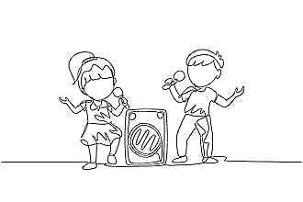
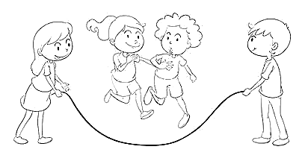

15.Define the pictures?

The End

